**EE 463 (Operating Systems)**

**Section: C3**

**Semester: Winter 2023**

Multithreaded C Program for Patient Room Access Control In A Hospital Using Pthread

|  |  |
| --- | --- |
| Name | ID# |
| Hayan Al-Machnouk | 1945954 |

**Course Teacher: Dr. Abdulghani M. Al-Qasimi**

**Department of Electrical and Computer Engineering**

**King Abdulaziz University, Jeddah, KSA**

Contents

**Main:** 2

**Display Thread:** 5

**Visitor Thread:** 6

**Doctor Thread:** 8

# **Main:**

function initializes random number of doctors and visitors, creates the display thread, and creates the doctor and visitor threads. It then waits for the display thread to finish, sends cancellation signals to all other threads, waits for them to finish, and releases all resources.

# **Display Thread:**

The function waits for a random period of time before printing the current status of the room. It acquires the room lock, prints the number of doctors and visitors in the room, and releases the lock.

# **Visitor Thread:**

The function first waits for a random period of time before attempting to enter the room. Then, it acquires the lock on room_lock and waits on visitor_cond until there are no doctors in the room and the number of visitors is less than MAX_ROOM_VISITORS. Once it is allowed to enter, it increments num_visitors and prints a message indicating that it has entered the room. The thread then releases the lock and waits for a random period of time before attempting to leave the room. When it is time to leave the room, it acquires the lock again, decrements num_visitors, prints a message indicating that it has left the room, and broadcasts on visitor_cond to unblock any waiting threads.

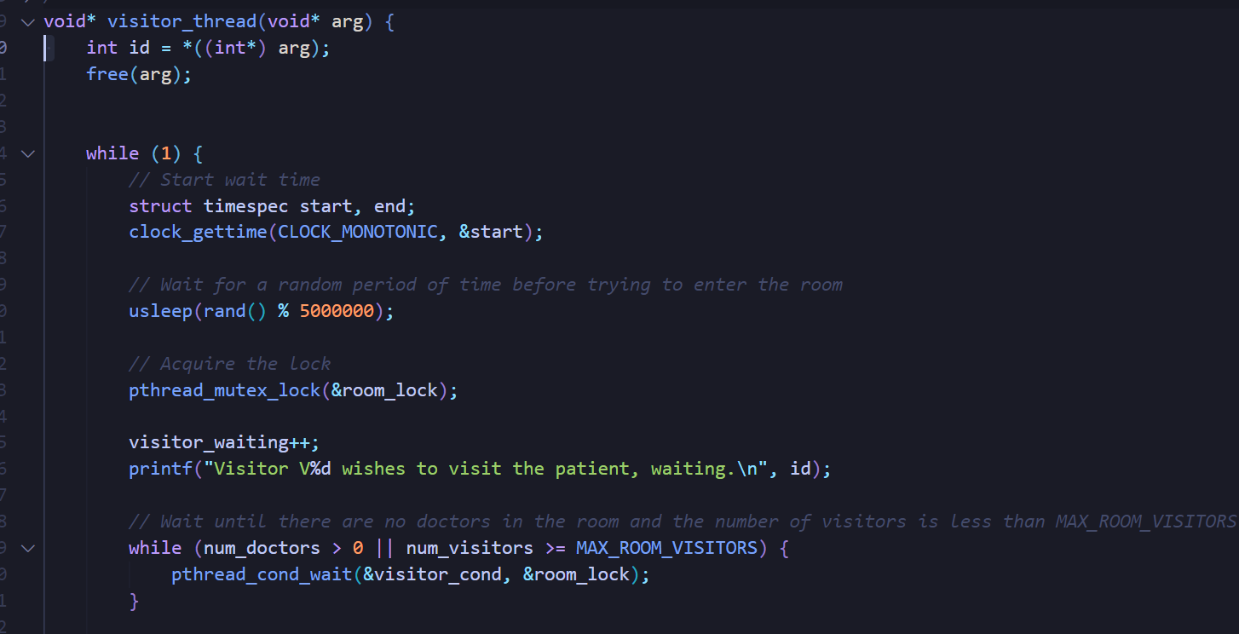

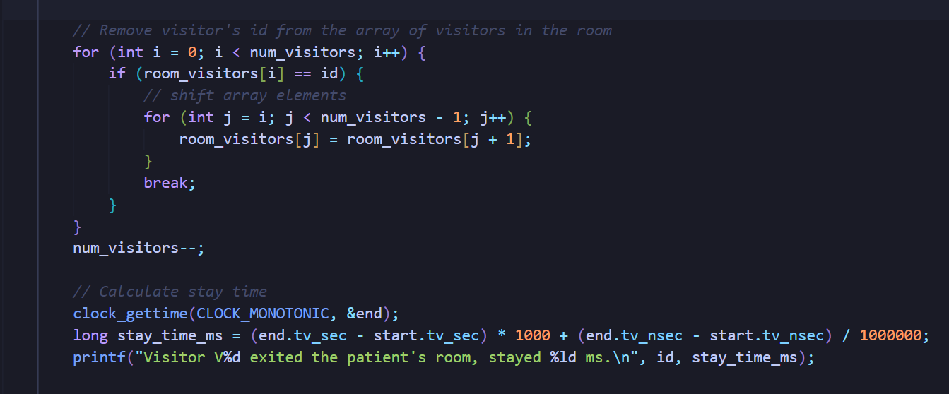

# **Doctor Thread:**

The function first waits for a random period before attempting to enter the room. Then, it acquires the lock on room_lock and waits on doctor_cond until there are no visitors in the room. Once it is allowed to enter, it increments num_doctors and prints a message indicating that it has entered the room. The thread then releases the lock and waits for a random period before attempting to leave the room. When it is time to leave the room, it acquires the lock again, decrements num_doctors, prints a message indicating that it has left the room, and broadcasts on doctor_cond and visitor_cond to unblock any waiting threads.

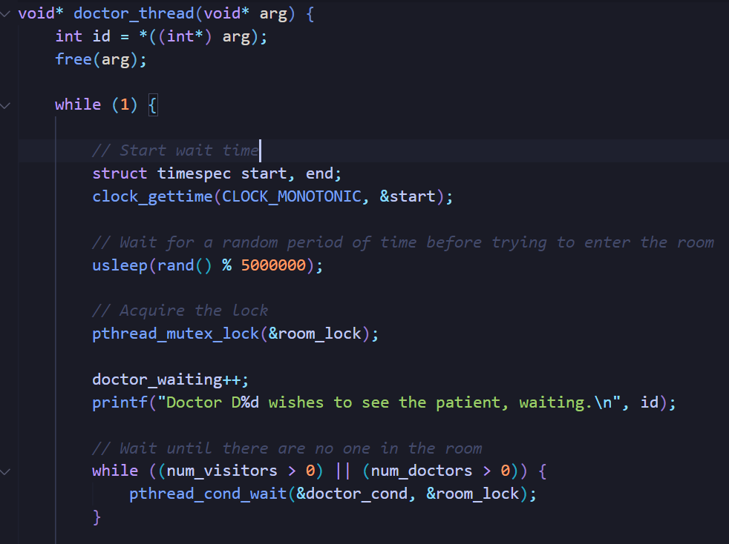

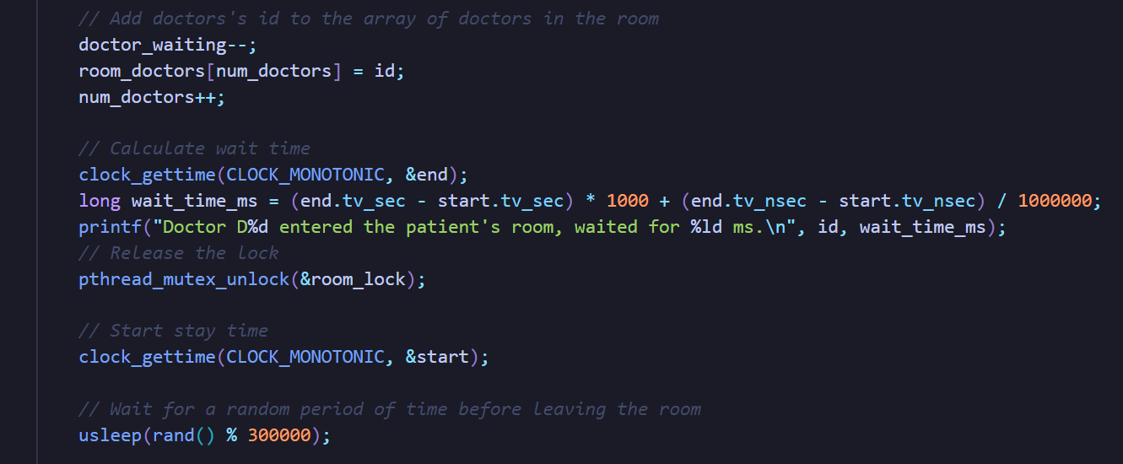

**Unit Tests for all the program can be found in the Tests Folder**